COURSE OUTLINE
BELONGING TO THE INSTITUTIONAL CATALOGUE OF COURSES
OF THE UNIVERSITY OF CRETE
- GENERAL
SCHOOL
ACADEMIC UNIT
LEVEL OF STUDIES
COURSE CODE |  | SEMESTER
COURSE TITLE
TEACHER
INDEPENDENT TEACHING ACTIVITIES  if credits are awarded for separate components of the course, e.g. lectures, laboratory exercises, etc. If the credits are awarded for the whole of the course, give the weekly teaching hours and the total credits |  |  | WEEKLY TEACHING HOURS |  | CREDITS
Add rows if necessary. The organisation of teaching and the teaching methods used are described in detail at (d).
COURSE TYPE
general background,
special background, specialised general knowledge, skills development
PREREQUISITE COURSES:

LANGUAGE OF INSTRUCTION and EXAMINATIONS:
IS THE COURSE OFFERED TO ERASMUS STUDENTS
COURSE WEBSITE (URL)
- LEARNING OUTCOMES
Learning outcomes
The course learning outcomes, specific knowledge, skills and competences of an appropriate level, which the students will acquire with the successful completion of the course are described.
Consult Appendix A
- Description of the level of learning outcomes for each qualifications cycle, according to the Qualifications Framework of the European Higher Education Area
- Descriptors for Levels 6, 7 & 8 of the European Qualifications Framework for Lifelong Learning and Appendix B
- Guidelines for writing Learning Outcomes
General Competences
Taking into consideration the general competences that the degree-holder must acquire (as these appear in the Diploma Supplement and appear below), at which of the following does the course aim?
Search for, analysis and synthesis of data and information, with the use of the necessary technology  Adapting to new situations  Decision-making  Working independently  Team work  Working in an international environment  Working in an interdisciplinary environment  Production of new research ideas | Project planning and management  Respect for difference and multiculturalism  Respect for the natural environment  Showing social, professional and ethical responsibility and sensitivity to gender issues  Criticism and self-criticism  Production of free, creative and inductive thinking  ……  Others…  …….
- SYLLABUS

- TEACHING and LEARNING METHODS - EVALUATION
DELIVERY
Face-to-face, Distance learning, etc.
USE OF INFORMATION AND COMMUNICATIONS TECHNOLOGY
Use of ICT in teaching, laboratory education, communication with students
TEACHING METHODS  The manner and methods of teaching are described in detail.  Lectures, seminars, laboratory practice, fieldwork, study and analysis of bibliography, tutorials, placements, clinical practice, art workshop, interactive teaching, educational visits, project, essay writing, artistic creativity, etc.  The student's study hours for each learning activity are given as well as the hours of non-directed study according to the principles of the ECTS | Activity Semester workload  Course total
STUDENT PERFORMANCE EVALUATION
Description of the evaluation procedure

Language of evaluation, methods of evaluation, summative or conclusive, multiple choice questionnaires, short-answer questions, open-ended questions, problem solving, written work, essay/report, oral examination, public presentation, laboratory work, clinical examination of patient, art interpretation, other

Specifically-defined evaluation criteria are given, and if and where they are accessible to students.
- ATTACHED BIBLIOGRAPHY
-Suggested bibliography on Eudoxus (Eudoxus code, title)
-Suggested bibliography:
- Related academic journals:

- Connection to the Sustainable Development Goals
Select the targets it connects to: (choose 2 to 5)
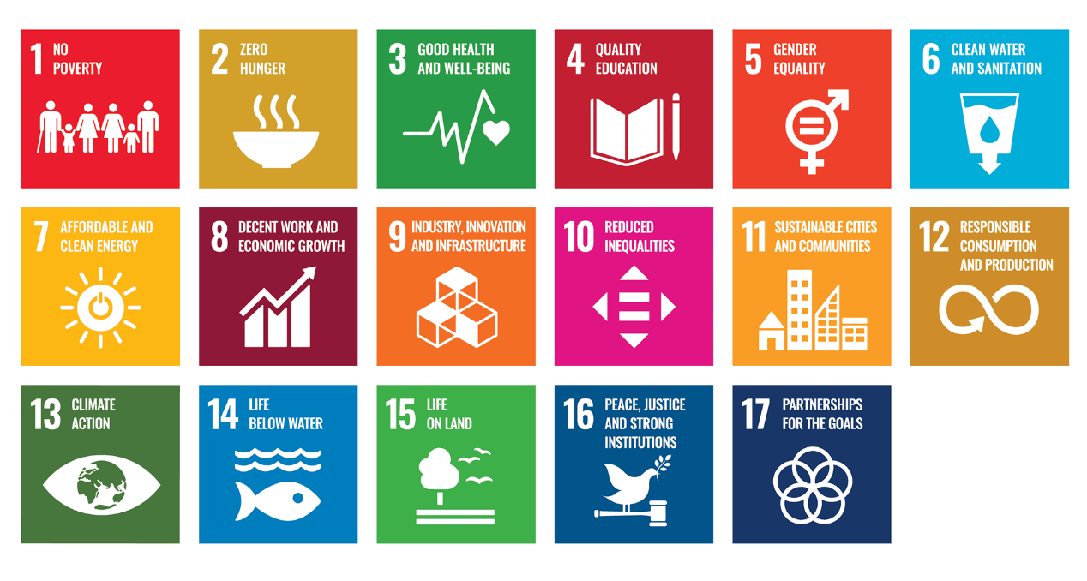
TAGS (choose 2 to 5)
TARGETS | Choose from the suggested words
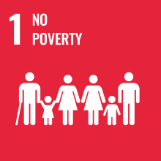 | Poverty Social protection Social cohesion Equal human rights Social resilience Social vulnerability  Social shocks/disasters Environmental shocks/disasters Development cooperation  Developing countries Least developed countries
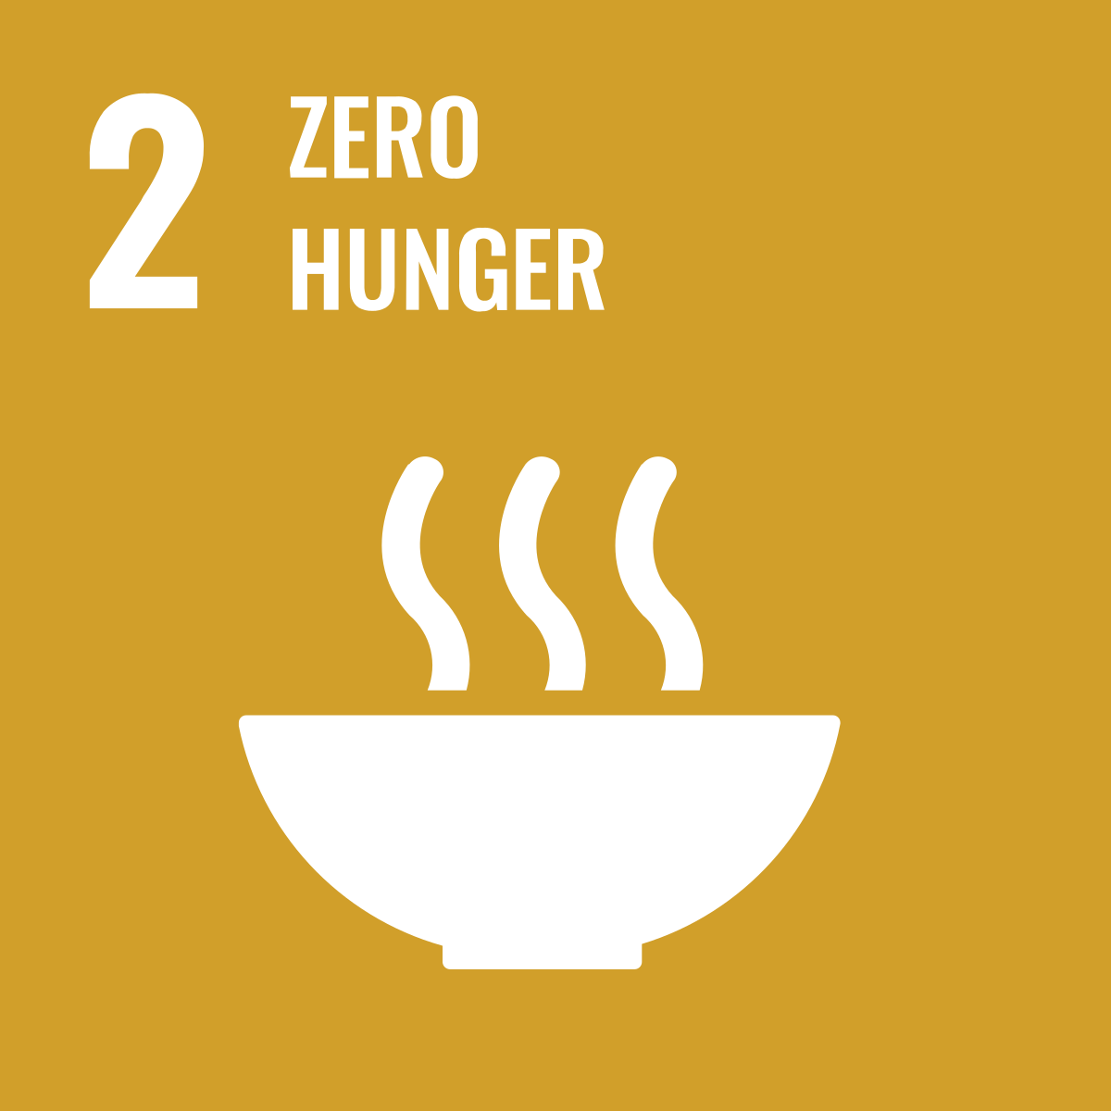 | Hunger Access to food Nutrition Agricultural income Food production Food security  Agricultural practices Ecosystems Climate change and adaptation Extreme weather Land quality  Soil quality Species variety Rural infrastructures Gene banks (plant and/or livestock)  Developing countries Least developed countries
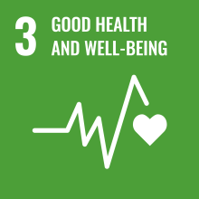 | Mortality (maternal and/or newborns) Epidemics Mental health Use of alcohol and/or narcotic drugs  Road traffic accidents Sexual/reproductive health  Universal health coverage (including medicines and vaccines) Pollution (air/water/soil)  Health services management (financing and/or workforce development)  Health risks (early warning, risk reduction, management)
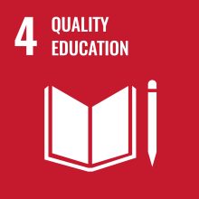 | Equitable access to education (primary, secondary, technical, vocational, university)  Early childhood (development and pre-primary education)  Skills (technical and/or vocational) Inclusive education Teachers’ qualifications and training  Lifelong learning
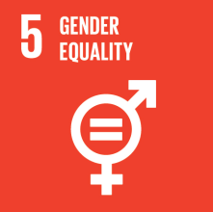 | Discriminations against women Exploitation of women Women’s inclusion in decision-making  Gender equality Empowerment of women and girls
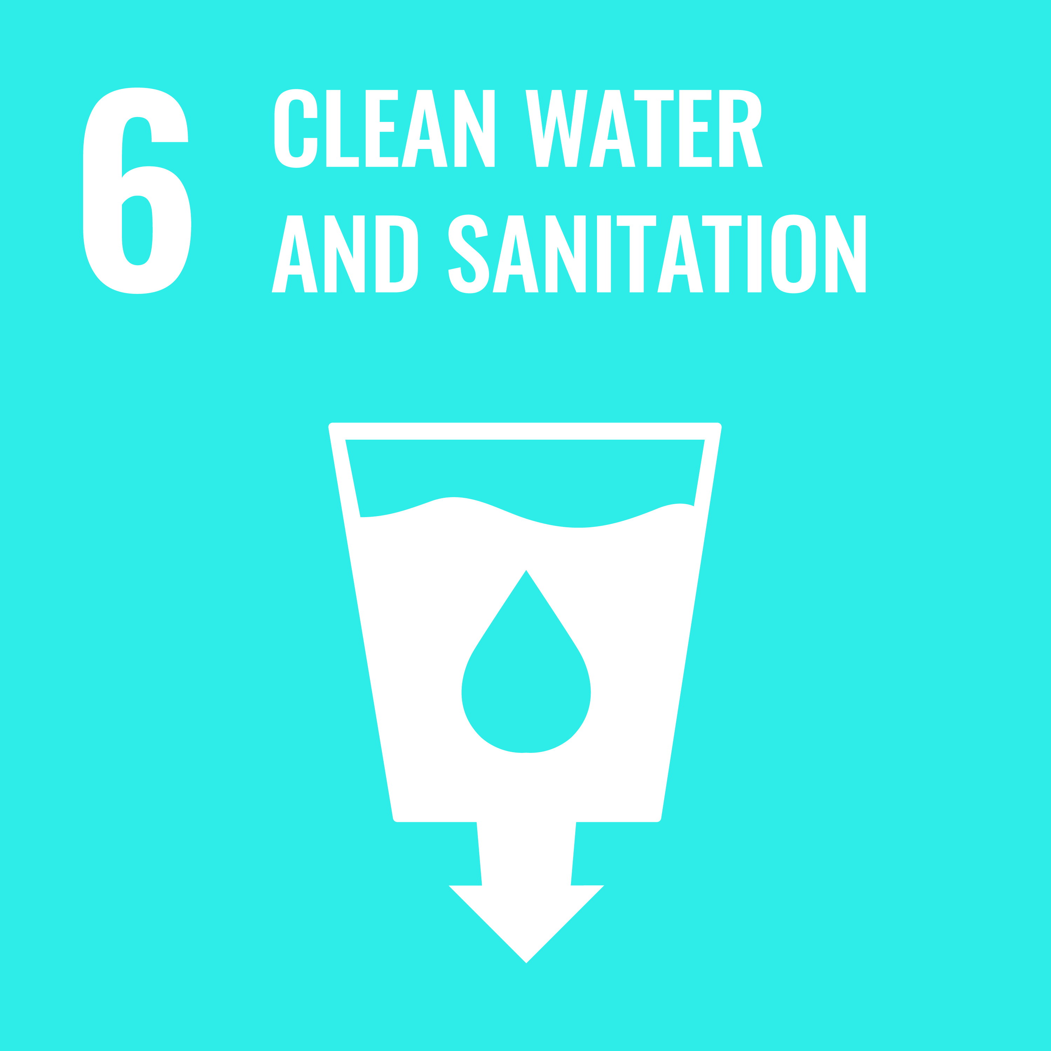 | Drinking water Sanitation and hygiene Water quality Water recycling/reuse  Water resources management Water-related ecosystems
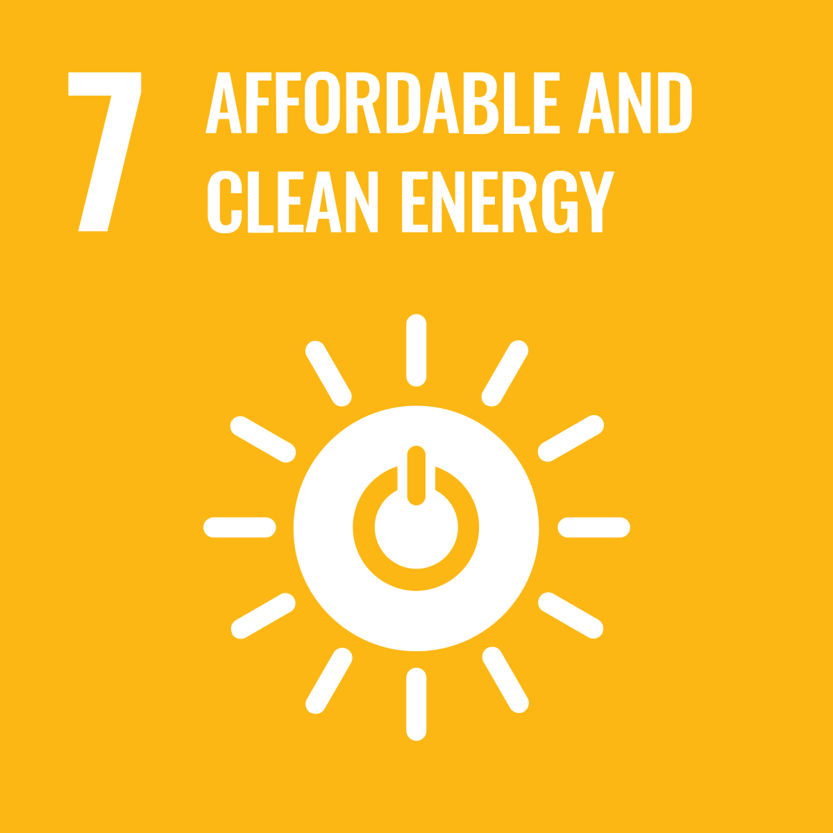 | Renewable energy Energy mix Energy efficiency Clean energy Energy technologies Fossil fuels  Developing countries Least developed countries
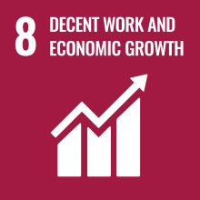 | Economic growth Technology upgrading and innovation Labour-intensive sectors Job creation  Entrepreneurship Creativity and innovation Micro-, small- and medium-sized enterprises  Financial services and/or institutions Resource efficiency Sustainable consumption and/or production  Decent work Unemployment Slavery and human trafficking Child labour Labour rights  Health and safety in workplace Migrants Sustainable tourism Developing countries  Least developed countries
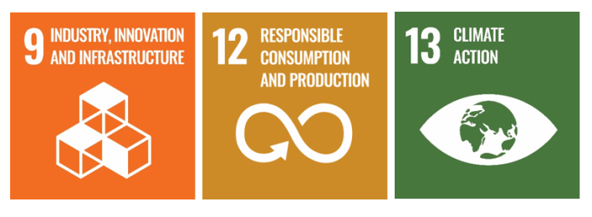 | Resilient infrastructures Industrialization (inclusive and sustainable) Employment  Least developed countries Developing countries Value chains and markets Resource-use efficiency  Technologies (clean and environmentally sound) Research and development Innovation  Industrial diversification Information and communications technologies internet access
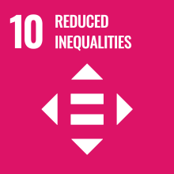 | Inclusion (social, economic and political) Inequalities reduction Non-discrimination laws and/or policies  Social equality Social protection policies Financial markets and institutions monitoring  Migration and mobility policies
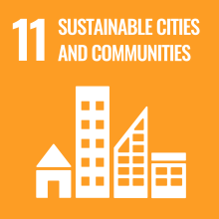 | Affordable housing Transportation systems (inclusive and sustainable) Sustainable urbanization  Human settlement planning Cultural heritage Natural heritage  Mortality caused by environmental disasters Urban footprint Urban air quality  Urban waste management Public spaces (safe, inclusive, accessible, green)  Regional development planning Least developed countries
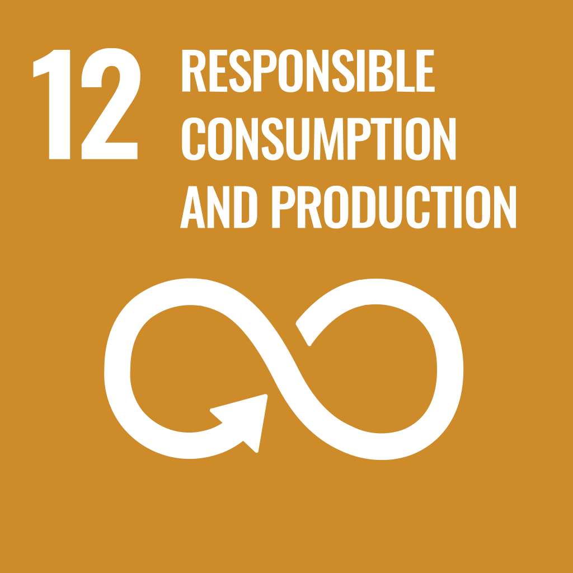 | Sustainable consumption Sustainable production Developed countries Developing countries  Νatural resources management Food waste Food losses  Waste management (prevention, reduction, recycling, reuse) Pollution management  Reporting sustainability information Public procurement  Sustainable tourism
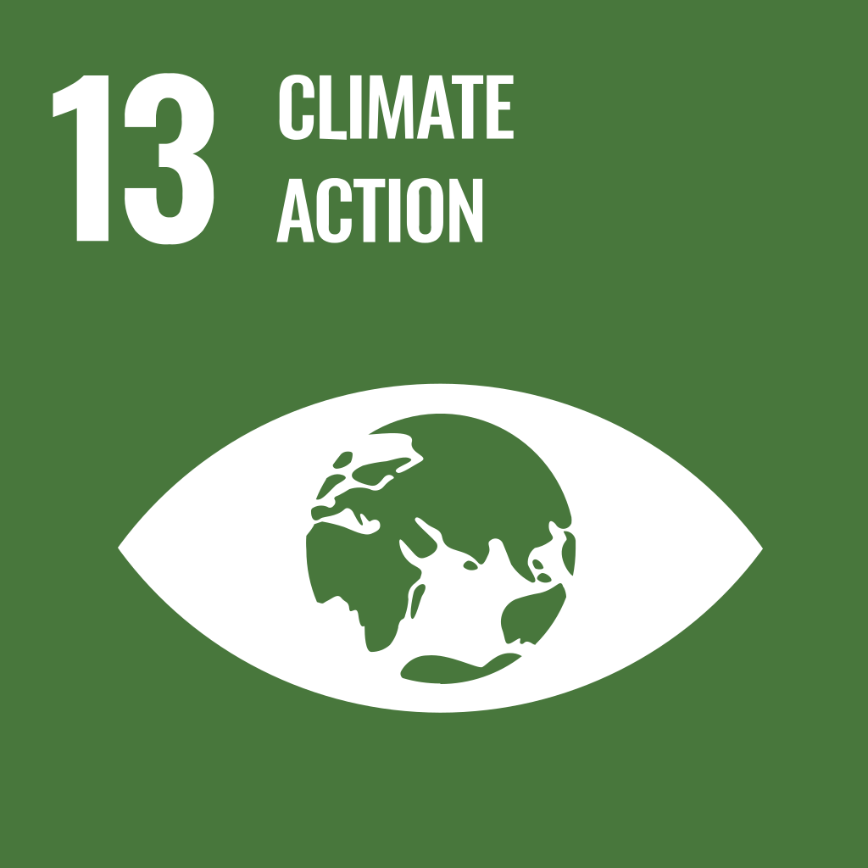 | Climate-related hazards Natural disasters Climate-change measures  Climate-change capacity (mitigation, adaptation, impact reduction, early-warning)
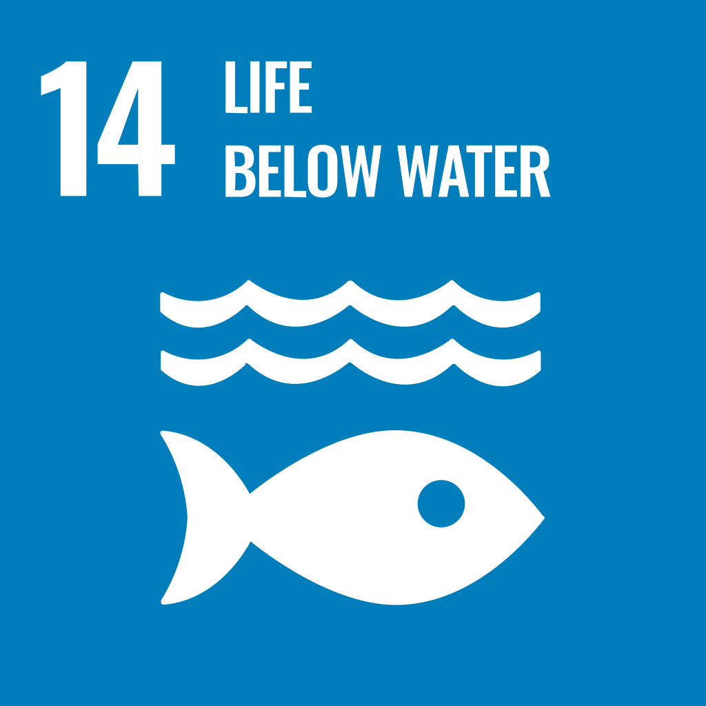 | Marine pollution Marine ecosystems Coastal ecosystems Ocean acidification Overfishing  Fishing practices Aquaculture Tourism Marine technology Marine biodiversity
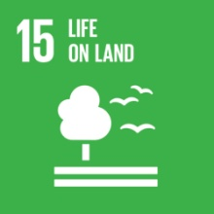 | Terrestrial ecosystems Forest management Desertification Land degradation Biodiversity  Deforestation Afforestation and/or reforestation Species in threat  Species under protection (flora and/or fauna) Wildlife products Invasive alien species  Local livelihood opportunities
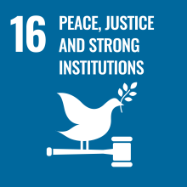 | Accountable institutions Inclusive institutions Transparent institutions Violence  Eliminate exploitation of children Equal access to justice Organized crime Corruption and/or bribery  Non-discriminatory laws
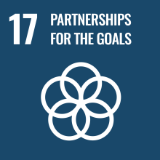 | Multi-stakeholder partnerships Developing countries Tax collection Debt sustainability  Debt financing Cooperation on science/technology/innovation  Technology (development, transfer, dissemination, diffusion)  Technology and innovation capacity-building

